**QuiZZies - a fun quiz game.**

This software allows users to play a quiz consisting of 20 questions. Each question can be one of the three types: Good, Tough or Complex. The quiz begins with the examinee enters their user name and roll/id . Then the user will get to choose which type of quiz he/she wants to perform first. The entire quiz carries a maximum of 100 marks. The number and type of questions chosen by user will determine their maximum possible marks. The grading, however, is carried out on an absolute scale of 100. However if a user wants to score higher grades then he or she has to attend at least two type of quiz for A or A+ . Marks Distribution is given below

**Grade Minimum Marks**

A+ 90

A 80

B+ 65

B 50

C 35

D 20

Marks below 20 will warrant F grade.

For instance, A user choosing to attempt only Good Questions can score a maximum of 60 marks and therefore, a B grade. To score higher, user must attempt Tough and Complex Questions too.

**Category :**

Good: Each question is of multiple-choice type with one correct answer. 3 marks are awarded for correct answer and 1 mark is deducted for wrong answer. No marks are deducted for leaving the question unanswered.

Tough: Each question must be solved, and answer reduced to a signed integer. 4 marks are awarded for correct answer and 2 marks are deducted for wrong answer. No marks are deducted for leaving the question unanswered.

Complex: Each question is of multiple-choice type with one or more correct answers. 5 marks are awarded for correct answer and 3 marks are deducted for wrong answer. No marks are deducted for leaving the question unanswered.

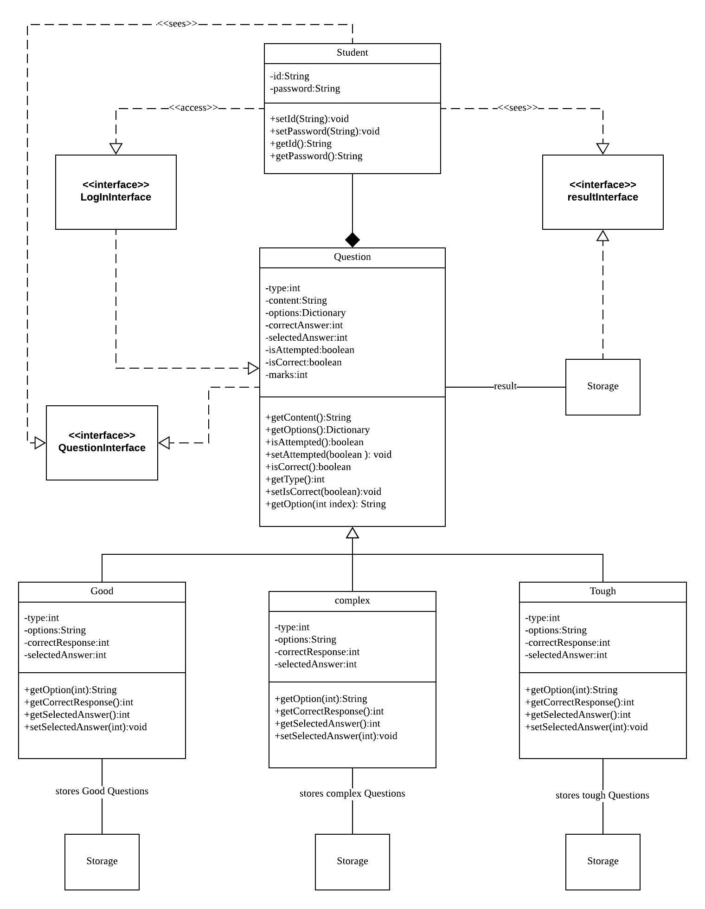The Class Diagram For QuiZZies is given below :

From this Class diagram,

The entire system consists of five classes which are Student class, Question class and inherited classes named Good, Complex and Tough. Also three interface classes for GUI are LoginInterface, QuestionInterface and ResultInterface.

**Student Class:**

Student class is basically for entering student’s details (i.e. username, password) the accessor and mutator methods are also present in this class.

**Question Class:**

The Question class shows how the whole system flow will go. Basically, here the interaction between the interface classes occurs. And also it is the parent class of the three inherited classes.

**Good class:**

Here it is one of the categories of questions, here mainly the basic or easy questions are stored for the QuiZZies.

**Complex Class :**

This class contains bit harder questions to be answered comparing good questions.

**Tough Class :**

This class is the highest mark achieve worthy class, if a student attempts this type of quiz he/she might know what the “tough” means.

**Interfaces**

First when the program starts the login page is shown including the detailed marking process is shown.

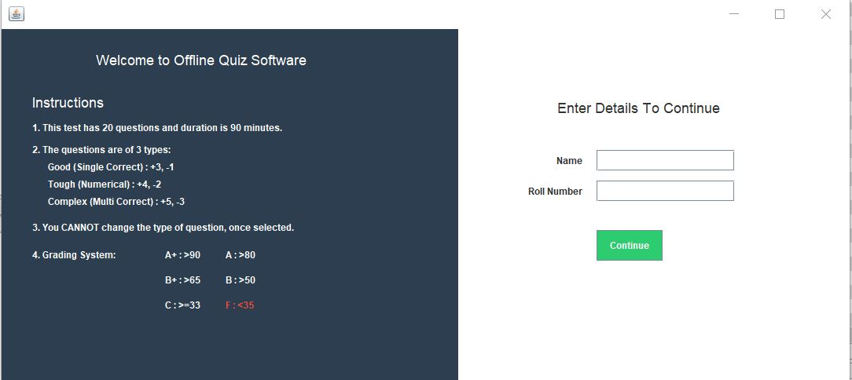

The name and roll number of the user has to be filled in and press the button “Continue”.

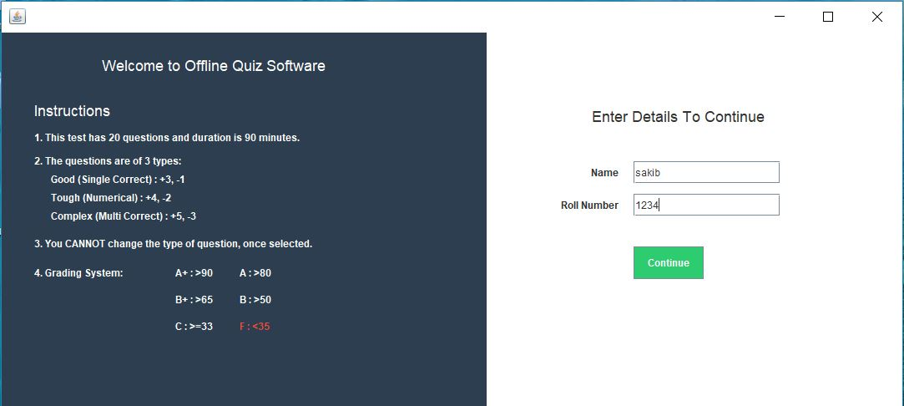

If the User does not fill in the text field for Name and Roll Number, then an error message box is shown which states “Please enter roll number and name to Start quiz!”

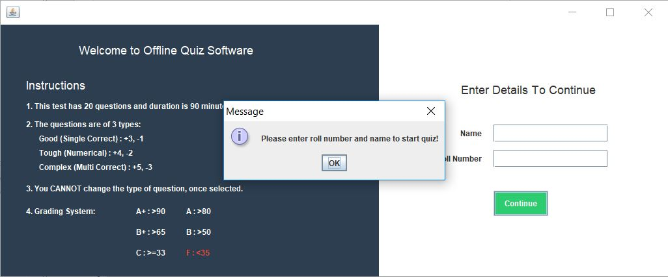

Once the user logs in, the system lets the user decide whether they want GOOD, TOUGH or COMPLEX questions and also the timer for 90 minutes starts.

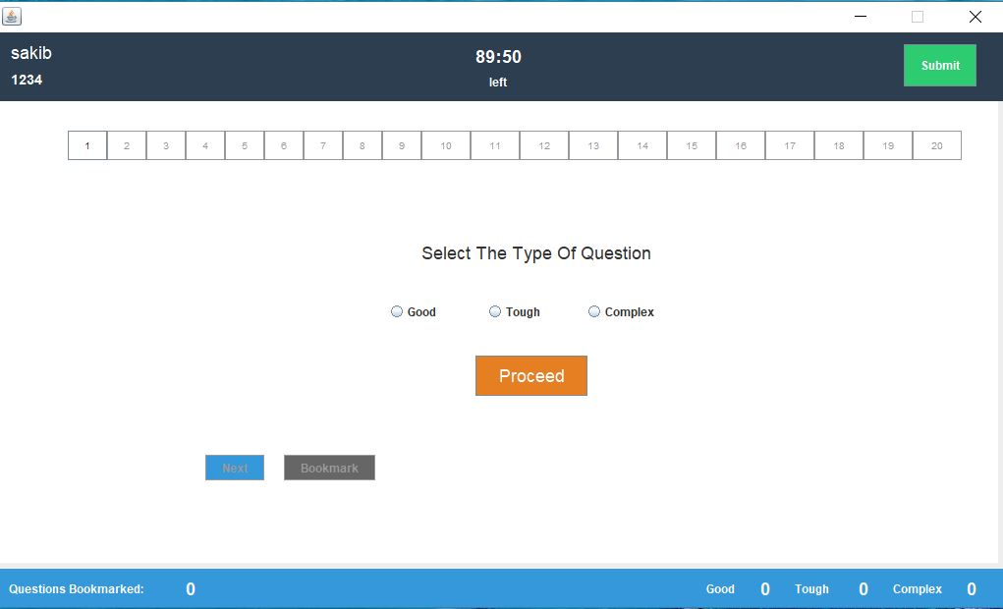

The user has to select the category of questions they want to answer and press the button “Proceed”.

The Interfaces for 3 categories are given below:

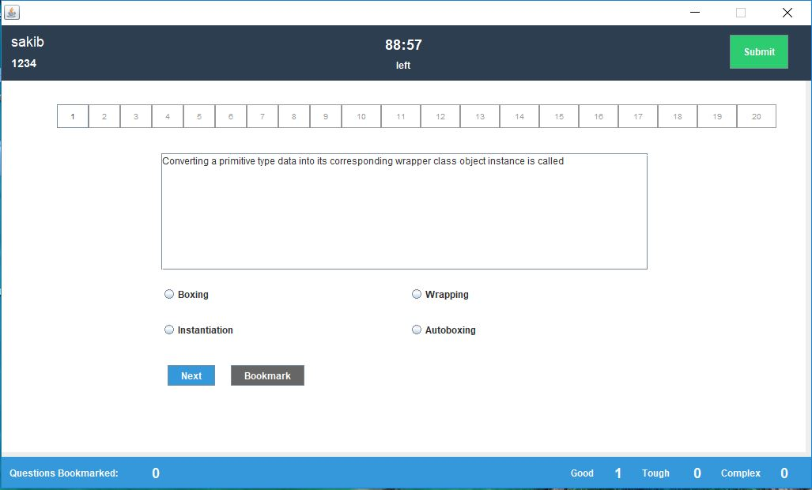

Interface for Good Questions

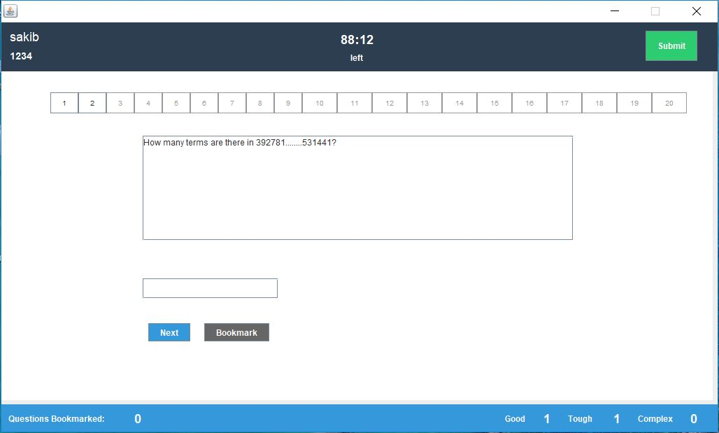

Interface for Tough Questions

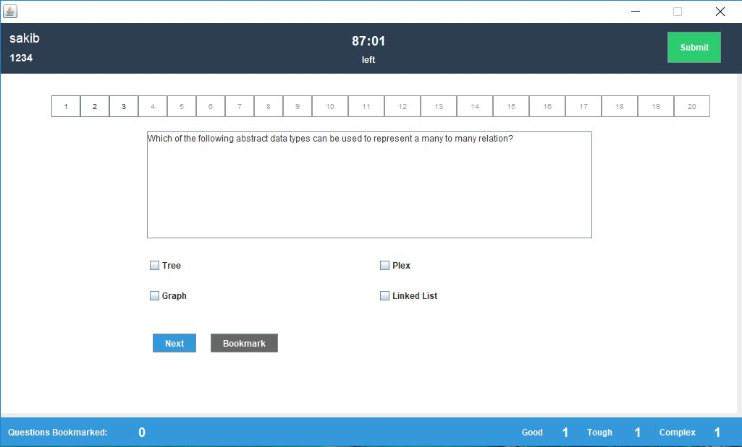

Interface for Complex Questions

Everytime the user answers a question, they have to click Next button to get to next question. And before the next question the user has to select the category they want to answer. If the user want to skip a question, they can bookmark the question and the system will show which question is bookmarked and the user can go back to that question and answer later. At the bottom of the page, the system will show how many questions are answered and how many questions are bookmarked.

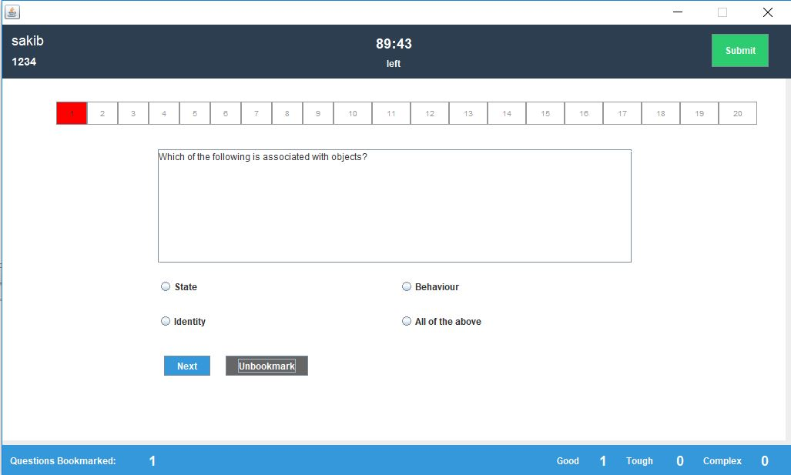

After finishing the quiz when the user clicks on “Submit” button, the result page is shown where it shows how many answers are correct and how many are wrong, It also shows the grade and marks obtained by the user.

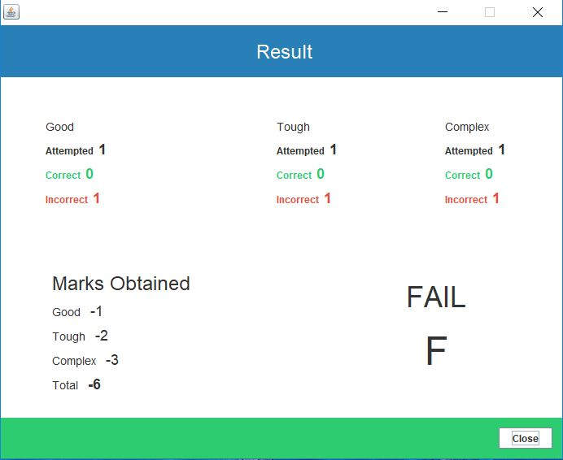

If the user clicks on “Close” button the program terminates.